LK01A LIQUID FLOW SWITCH
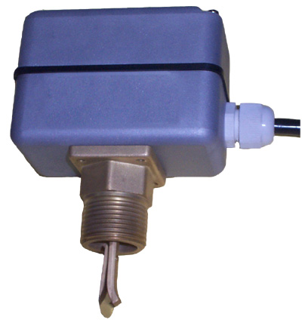

DESCRIPTION
LK01A Liquid Flow Switch is used in the circumstance where chain effect or cut-off protection is needed. It is to supervise the liquid flow rate through the pipes. When liquid inside the pipe circulates or cuts off, flow switch will correspondingly alters the ON/OFF state so as to control and protect external devices. Liquid Flow Switch is suitable for any liquid medium that makes no corruption on brass and tin-bronze and takes no effect on air-proof performance.

CHARACTERISTICS
- Suitable for pipes from 3/4" to 8"
- Applicable to cool/heat water system
- Strong die-casting aluminum alloyed casing and cover
- R1 or R3/4 male thread joint; Easy mounting
- Dependable and durable parts such as forged brass, tin bronze, stainless-steel and high-strength flameproof engineering plastic
- Complete airproof design

INSTALLATION
- Mount on return pipes
- Mount on horizontal pipes
- Keep a certain distance from sources of turbulences (Elbows, valves, pumps, etc) so as to ensure steady working flow. Recommended minimum distance is equal to 5 times of the pipe's diameter

ADJUSTMENT OF FLOW RATE SETTING
Flow setting device is combined by adjusting screw and spring. Fully tighten the screw to obtain minimum flow rate setting, fully loosen the screw to have maximum flow rate setting. The following table gives the values for limiting flow rate settings in relation to the pipe diameter and blade length. The LK01A is supplied ex-factory with the setting screw fully tightened (minimum setting).
MODEL | DIAMETER  (inch) | CONNECTION  THREAD | BLADE LENGTH  (mm) | FLOW RATE WITH  MINIMUM SETTING  (l/h) |  | FLOW RATE WITH  MAXIMUM SETTING  (l/h)
 |  |  |  | SWITCH ACTION | SWITCH RETURN | SWITCH ACTION | SWITCH RETURN
LK01A-20 | 3/4″ | R3/4 | 29 | 1 | 0.3 | 2 | 1.5
LK01A | 1″ | R1 | 34 | 1.3 | 0.8 | 2 | 1.6
LK01A | 11/4″ | R1 | 34 | 1.5 | 1 | 2.6 | 2
LK01A | 11/2″ | R1 | 57 | 1.9 | 1.3 | 3.3 | 2.6
LK01A | 2″ | R1 | 57 | 3.2 | 2.2 | 6.6 | 6.1
LK01A | 21/2″ | R1 | 88 | 4.2 | 3.2 | 8 | 7
LK01A | 3″ | R1 | 88 | 6.3 | 4.7 | 12 | 11
LK01A | 4″ | R1 | 88 | 8.5 | 6 | 18 | 17
LK01A | 5″ | R1 | 167 | 13.1 | 9 | 27 | 25
LK01A | 6″ | R1 | 167 | 17.2 | 12 | 33 | 31
LK01A | 8″ | R1 | 167 | 47 | 39 | 94 | 91
The pre-set bolt has been adjusted before ex-factory. Users cannot adjust by themselves. The adjustable bolt can be adjusted and set according to special requirements. (See Fig. 1)

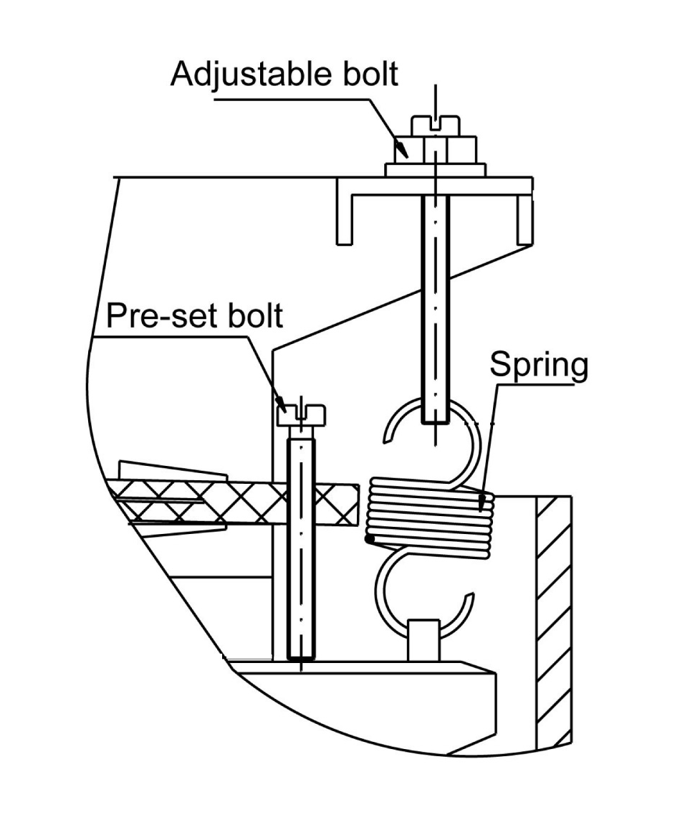
TECHNICAL DATA
- Rated voltage, rated current: 250VAC, 10(3)A
- Working pressure: 1.0MPa
- Max. testing pressure: 1.5MPa
- Max. fluid temperature: 110℃
- Storage temperature: -20～80℃
- Weight: 0.8Kg
- Protection class of casing: IP64/IP67

MATERIAL
- Casing and cover: Die-casting aluminum alloyed
(Fig.1)

- Bellow: Tin-bronze
- Blade: Stainless steel
- Joint: Forged brass, R1 or R3/4 male thread
- Wiring: 4×1.5mm² cable gland (Length made by order)

DIMENSIONS
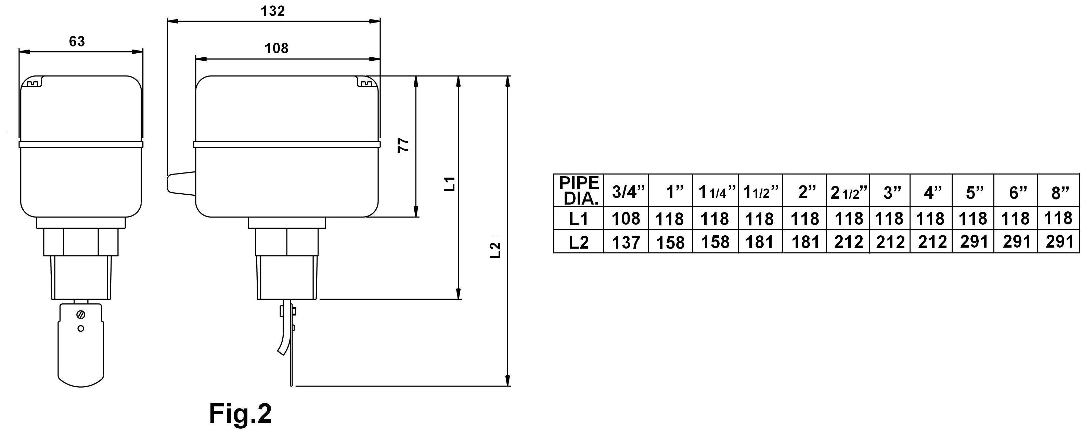
WIRING DIAGRAM
- N.C.-COM contact is normally-closed (When flow switch is acted, the contacts disconnect.)
- N.O-COM contact is normally open (When flow switch is acted, the contacts connect.)

(Fig. 3)

