http://www.eljentechnology.com/index.php/products/zinc-sulfide-shifting-plastics

Zinc Sulfide Disc & Sheets
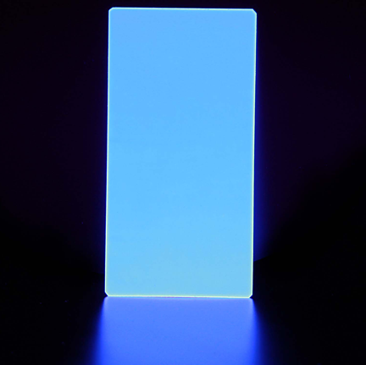
Eljen Technology | Description
EJ-440 | ZnS:Ag Sheets and Discs 0.010 in. thick  (Available in sheet sizes: 8.5 in. x 11 in. or 12 in. x 12 in.)
EJ-442 | ZnS:Ag Coating on Acrylic Plastic or Glass
EJ-444 | EJ-212 Plastic Scintillator with ZnS:Ag Coating
 | *SDS available upon request

EJ-440 phosphor sheet | distributed by

This product consists of a very uniform deposit of blue-emitting P22 type silver activated zinc sulfide phosphor applied to one side of clear polyester plastic sheet. This is specifically intended for alpha particle detection, and the phosphor layer density is sufficient to completely absorb common alpha particles such as those from Am-241.
The phosphor layer is smooth and sufficiently robust to stand up to normal handling. The sheets are quite flexible and can be easily cut with a scissors or paper cutter. The EJ-440 material has often been used to successfully replace the Product #ASP3 ZnS:Ag sheets formerly manufactured by the Wm. B. Johnson Company. EJ-440 is available in full-size sheets measuring 216mm x 279mm ( 8•1/2" x 11" ) and is also supplied in 49mm dia. ( 1.94" ) precut discs. This material is very stable, and its shelf life at room temperature is at least two years.
Eljen Technology also offers EJ-444 which consists of the same ZnS:Ag coating on thin plastic scintillator sheets typically 0.25mm thick for dual alpha-beta detection.

Physical and Scintillation Constants:
Light Output, % anthracene | 300% | 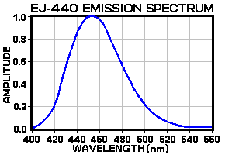
Wavelength of max emission, nm | 450
Decay time, nSec. | 200
Phosphor Density, mg/sq.cm | 3. 25
Phosphor Density range, mg/sq.cm | +/-0. 25
Thickness of polyester film, mm | 0. 25
Density of polyester film, mg/sq.cm | 36
Density, g/cc | 1. 032
chemical compatibility | The adhesive is soluble in common alcohols and  other organic solvents. It is insoluble in water.

Eljen Technology Headquarters
Eljen Technology
1300 W. Broadway
Sweetwater, Texas 79556
United States
Phone: (325) 235-4276
Toll Free Phone (US and Canada): (888) 800-8771
Fax: (325) 235-0701
email: eljen@eljentechnology.com
www.eljentechnology.com

Overseas Dealers
China
United Kingdom
Germany
Europe (excluding UK and Germany)
India
Korea

Home
EKM
Eckhard Kruse
Beratungs
Vor dem HaBel 8
Brackel
D-21438
Germany

ekm.kruse@t-online.de
49 041854027
49 041854123

Home
Scionix
Paul Schotanus
PO Box 143
Bunnik
3980 CC
NETHERLANDS

scionix@scionix.nl
31 30 657 0312
31 30 656 7563

